

Your Guide To Events and Activities At The Mall for October 2005

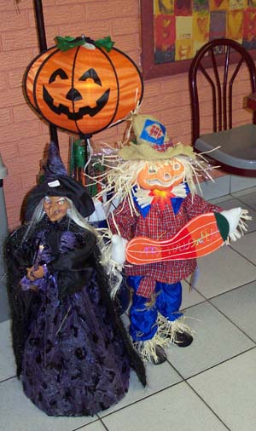
2nd Annual Halloween Costume Day Will Be Held On Sunday, October 30

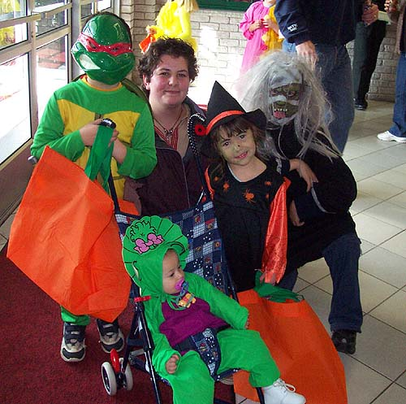

Ghosts, goblins and all kinds of other creatures will once again fill the hallways of the Hanmer Valley Shopping Centre on Sunday, October 30, 2005 for the 2nd Annual Halloween Costume Day At the Mall. Last year over 1200 little creatures visited all of the stores in the shopping center looking for treats and goodies to fill their Halloween Bags. This year we are expecting even more youngsters to show up. Dress up your pre-teen age child in a costume and come to the mall any time between 12 noon and 4 p.m. It will take about an hour to go from store to store collecting your treats in climate-controlled comfort. Expect to meet many of your friends and neighbours while you are walking around the mall with your children. This event has taken on the semblance of an old-fashioned neighbourhood Halloween – Just like you remember when you were kids. So don’t forget to mark it on your calendar. Bring the whole family for a day of fun!
SUNDAY, OCTOBER 30
12 NOON TO 4 P.M.
AT THE MALL

YOU ALSO HAVE A CHANCE TO WIN GREAT PRIZES ON OUR PRIZE TABLE

Nicole Brunet Displays Many Products Available At Beswick Denture Clinic
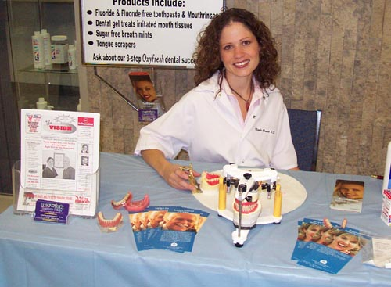

Nicole Brunet D.D. is shown in the photo at her information table during Valley East Days at the Mall. Nicole is now working with Doug Beswick at the Beswick Denture Clinic where she is looking forward to a long career serving local residents. Increasing the level of public awareness and education about the services and products that are available on the market today are two of Nicole’s primary goals as she establishes herself in her practice. Customers can stop in to the office at any time to have a look at the selection of products on display or just to pick up one of the information brochures that are available in the waiting room. If you find a product that you can use, you will also be pleasantly surprised at the great prices. Nicole and Doug are never too busy to discuss your denture needs or concerns. If you think you may be in need of denture services, simply stop by and talk to either practitioner. Give Nicole or Doug a call today at 969-8086.

Sports Mouth Guard Clinic To Be Held Every Month At The Mall
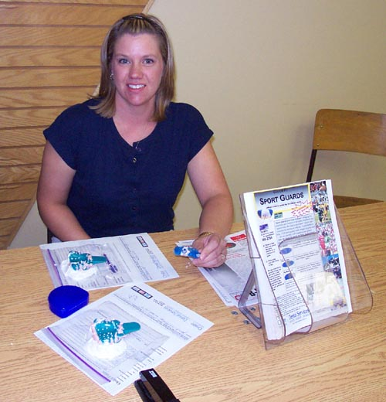
Sheryl Sasseville will be on hand each month at the Hanmer Valley Shopping Centre providing parents and athletes with important information about mouth guards and how they can prevent major, long term injuries in a wide variety of sports and recreation activities. Sheryl, along with her husband, Rick, operate a company called Onsite Dental Services. You can find out about their company by going to the web site at www.onsitedentalservices.ca. If you or one of your children participate in a sport or recreation activity that includes the risk of the sudden jarring of your head, or if there is a chance that your teeth may banged together from repetitive up and down motions, then it would be a good idea to visit Sheryl during one of her clinics to see how you can reduce the risk of concussions, jaw damage, or simply chipping of your teeth. Minor Hockey players must wear a mouth guard as part of their mandatory equipment. This alone should tell you that this piece of equipment is extremely important. Sheryl will be holding a clinic at the Hanmer Valley Shopping Centre on Saturday, October 22, from 1 p.m. to 4 p.m. You can simply drop in or call her first to schedule an appointment. Call 665-2755 and talk to Sheryl to find out more information on why a custom-fitted mouthguard is being used by more and more athletes concerned about their head safety.

Tips On How To Save For Your Child’s Post-Secondary Education

When it comes to the cost of post-secondary education, you can pretty well be certain of one thing – it is going to cost a lot! And anyone with a child in elementary school today knows that the cost is definitely going to be much more by the time your son or daughter graduates from secondary school. The Hanmer Valley Shopping Centre and Angel Piche, a financial consultant who was born and raised in Valley East, and who has returned home to begin a career, will be sponsoring a series of special information sessions at the mall for parents who would like to get some valuable tips on how they can prepare for the inevitable. According to Angel, “There are a lot of options available for parents today who are interested in saving for their child’s education. The most important thing is to first of all become aware of those options and then begin taking action as soon as possible.” Indeed, if you ask any parent of a child who is now in post-secondary school, they will tell you that it seemed like just yesterday when that very same child began kindergarten. It would be a shame if your child was denied an education for purely financial reasons. The information sessions on Post-Secondary Education Savings will be held on Saturday, October 15 and 22 from 9:30 a.m. to 4:00 p.m. They will once again be held on November 6 and 19. If you have any questions about the sessions, you can call Angel Piche at 674-4551 Ext. 401.

4th Annual Golf Tournament Raises $1200 For Breast Cancer Research
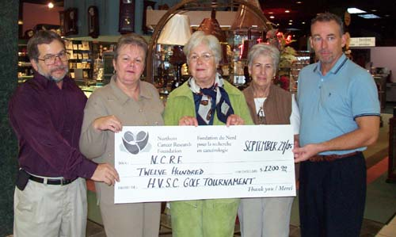
Maureen Lacroix, chair of the Board of the Northern Cancer Research Foundation, is shown in the middle of the photo receiving a cheque in the amount of $1200 which was raised during the 4th Annual Hanmer Valley Shopping Centre Charity Golf Tournament which was held in September. Included in the photo are Peter and Valerie Pitre, on the left, as well as Lucy Beauchamp and Mike Biglow on the right. Peter, owner of Just For You Cards and Gifts, and Mike, owner of J.B. Jewellers, are the co-organizers of the tournament. The money will be used for Breast Cancer Research. To date, well over $3000 has been raised through the tournament for this cause.

Erin Sprunt Wins Marineland Trip

Erin Sprunt was the winner of 4 free passes to MarineLand in Niagara Falls during a special contest which was sponsored by Just For You Cards and Gifts in August.

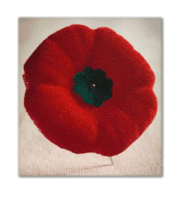
Don’t Forget To Get Your Remembrance Day Poppy From The Capreol Legionaires on October 28 & 29
Thank You
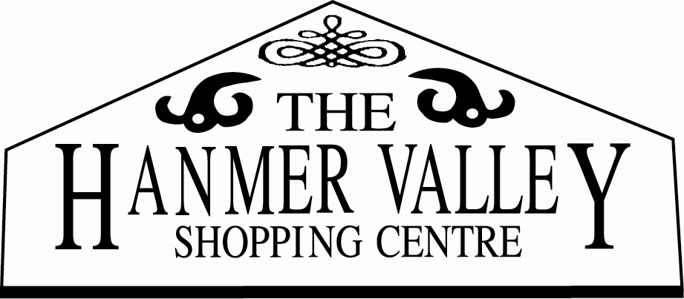
This Month At The Mall

It’s shaping up to be a very busy month at the mall in October! Already we have several groups coming in to the mall on different dates. Keep the following calendar handy, but also make sure you check The Vision Paper every week to get up to date information on what is going on at the mall!

THE LIONS CLUB will be selling tickets on the Dream House Draw from October 11 to 16. Make sure you don’t miss out on these $20 tickets. You could win hundreds of thousands of dollars worth of prizes.

ST. KEVIN’S PARISH CWL will be selling tickets on October 14 and 15. They are also promoting their annual Christmas Tea which is always a major event in the Valley.

THE CONOISEUR “COIN GUY” will be back again in October on October 21 and 22. He will have some excellent gift ideas for those coin experts in your family.

THE JEHOVAH WITNESSES will be setting up their attractive display booth on October 22. Every month this group provides us with information about their organization.

THE GROTTO ASSOCIATION will have a table set up on October 21 and 22 selling tickets and providing information about their major renovation project.

MONTHLY MOUTH GUARD CLINIC will be at the mall on Saturday, October 22 from 1 to 4 p.m. for anyone involved in contact sports such as hockey or ringette.

AN EDUCATION PLANNING SESSION will be put on at the mall on October 15 and again on October 22 for people interested in finding out about saving for education.

THE ANNUAL POPPY BLITZ will be conducted by the Capreol Legion on October 28 and 29. This is an annual event organized by Gerry Sorel.

CHOLESTEROL CLINIC will be held again on the last Friday of the month. This month the clinic will take place on Friday, October 29 from 10:00 to 2:00 p.m.

ANNUAL HALLOWEEN COSTUME DAY will be held on Sunday, October 30 from 12 noon to 4 p.m. Make sure you come early and enjoy the treats being given out by merchants.


www.valleyeasttoday.ca

ONLINE MALL FLYER

The ONLINE MALL FLYER is quickly becoming a very popular section of the Community Web Site at www.valleyeasttoday.ca. The flyer is filled with colour photos of a wide variety of merchandise that is on sale or available from sponsoring merchants in the Hanmer Valley Shopping Centre. This month the ONLINE MALL FLYER is sponsored by the following merchants. Please give them your support:
Beswick Denture Clinic | Stan Thomas (Solicitor) | Dixie Lee Chicken
The Pet Palace | Nature’s Apothecary | Sole Mates Family Footwear
Lou’s Shoe Repair | Hanmer Home Hardware | The Source by Circuit City
The Cutting Boutique | The Floral Nook | G33KTEK Computers
Gallery & Brew Shop | The Dollar Klub | Drs. Dunlop & Labrecque Optometrists

COMMUNITY BULLETIN BOARD IS AVAILABLE FREE OF CHARGE FOR LOCAL GROUPS
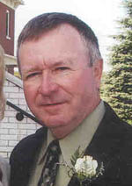
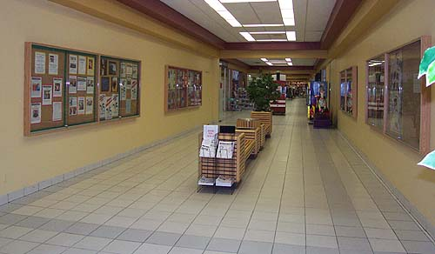
Once again, as the Public Relations Director for the mall, I would like to encourage all community groups, schools, churches, and sports organizations to take advantage of the excellent promotional opportunity to use our community bulletin boards which are located in the East Wing of the shopping center. There is no charge to post information and it is definitely a popular place for shoppers. Many people stop by and read the information on the Board. Simply drop your information to the mall office or give me a call at 969-7215 and we will get your group on display.
Robert Kirwan, Public Relations Director


The Hanmer Valley Shopping Centre is much more than just a place to go for groceries or to pick up your retail supplies. It is one of the largest indoor walking trails in the Greater Sudbury District. Better yet, it is open seven days a week from as early as 7:30 a.m. in the morning. Bring your favourite walking shoes any time of the day and enjoy a leisurely walk around the mall. Stay as long as you wish.

THANK YOU FOR YOUR CONTINUED SUPPORT
The merchants of the Hanmer Valley Shopping Centre wish to thank all of our loyal shoppers for their continued support and best wishes. Have a great month

